1. **Abstract (what we want to do)**

In this study we can observe data related to students of 15 year of age coming from European countries among which there’s a significant number of immigrant students. How do immigrant students face up when compared to native students? Which are the main differences in their scholastic, familiar, psychological characteristic? Which features are most important when it comes to their scholastic success? How can we take example from the best European countries with respect to integration to help these students?

1. **Introduction/objectives (how we want to do it)**

The dataset we focused on is based on some tests given to students, their parents and their schools, regarding both scholastic knowledge and social questions.

After a general visualization of the dataset and an analysis of it through Manova tests and Clustering methods, we focused on the students’ scores in math and reading noticing that there were differences between native and immigrant students in term of their results.

We proceeded with a deeper analysis and built some models, which highlighted that the score of a student is affected by some features as his socioeconomic state, the amount of time he dedicates to study, his class size and some others, besides his hard work and study. The obtained results suggested us some ways to help the lagging students, who most of the times were the immigrant ones, understanding the points that could be improved.

Then, focusing on schools and proceeding with a Multinomial Logistic Regression, we clustered schools with respect to some features that affected the results of their students, highlighting what makes a school the best in terms of results and of integration.

1. **Materials & Methods (how we did it)**

* Data selection

Starting from the data of Pisa’ OECD program of 2018, which contains student and school answers to standardized questionnaires, we restricted our analysis to 10 selected countries which had a sufficient sample of immigrant students: Austria, Belgium, Denmark, Germany, Great Britain, Italy, Luxemburg, Spain, Sweden, Switzerland.

Since the number of covariates available was more than 1000 (one for each questionnaire answer), we selected the most relevant ones related to our focus on immigration. Some of the questions answered by the students were already aggregated by Pisa’s group and resulted to be the most complete.

The features selected range over many fields: ESCS status, Immigration status, teacher support, sense of belonging, class size, at home weekly learning time, etc.

* Clustering

We first qualitatively visualised our dataset trough clustering. Using k-means on the dataset containing the observations of all european students, we came up with three balanced clusters which are not perfectly divided but seem to confirm our hypothesis that immigrants are generally less successful at school.

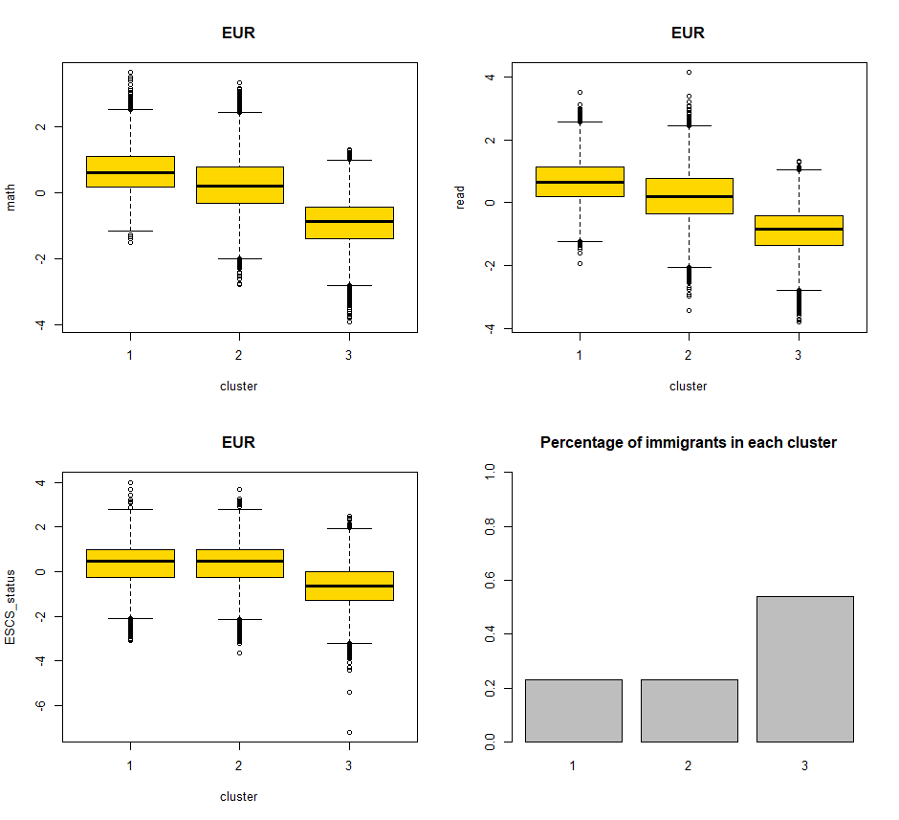

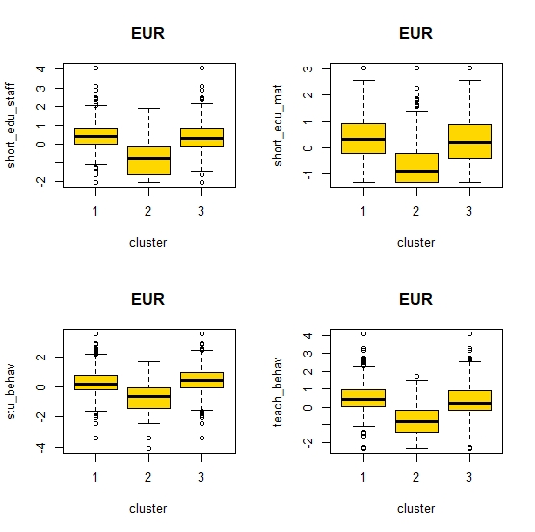

The cluster linked to the best performances contains only the 23% of the total number of immigrants, while the worst one contains the 54% of them. Moreover, from the analysis of the other features of the clusters it’s clear that immigrants often attend poorer schools with a shortage of material and staff, where there is generally a school climate that hinders learning.

* Manova

We then used manova to get statistical evidence for our hypothesis of there being differences between native and immigrant students in math and reading scores. Then we further investigated other differences between these groups.

The main hypothesis was confirmed for all European countries (except Great Britain). By ranking them, we see that Great Britain is the country with least score difference, while Denmark is the worst among the selected countries.

In addition, learning times for immigrants are consistently more in all countries with respect to natives’ times; this result highlights that usually the failure of immigrants is not due to a lack of commitment and study.

From other inspections…seba continua

* Linear models

After assessing the presence of differences in scores between immigrants and natives we tried to understand which features are most important for a student’s scholastic success, to find the optimal way for schools to help lagging students and to have a better integration system.

By focusing our aim on three datasets (European aggregated dataset, Great Britain as the most performing country wrt integration, and Denmark as the worst one) and using as our target variable the scores of math and reading, we selected the best model through backward selection.

We started with the European dataset to look for general trends: we found out, as we expected, that being an immigrant student, who mainly speaks his language and not the one of the country he lives in, has a negative effect on the scores, as well as having parents who are not highly educated and being bullied at school.

Moreover, it was clear that a school with a shortage of educational material and staff influences its students’ achievements, especially if they are immigrant who probably need an additional and more careful help from teachers.

On the other side, there are also positive effects, given mostly by the socioeconomic state of the student.

We decided to investigate more deeply the datasets of Great Britain and Denmark, trying to highlight if there are features that are more relevant than others in determining the integration gap between these two countries.

First of all, as we expected, we noticed that the feature ‘immigration’ was not significant anymore in the Great Britain model. On the contrary, in Denmark being an immigrant has a strong negative effect on the school success, also worsened by the interaction with other covariates as the student-teacher ratio and being bullied.

* LMM

To measure the effect of living in a certain country on the students’ performance, we implemented a linear mixed model aggregating the observations through countries, keeping as target variables math and reading scores. To better focus on the aim of our analysis we also added a random effect associated with the variable immigration.

We performed two other mixed models in order to emphasize the differences across schools in Great Britain and Denmark. Indeed, we aggregated the students through their schools trying to detect the main reasons why Great Britain is an effective model of integration as opposed to Denmark.

The random effect given by the country is significant and increase its relevance once added the immigration random slope, both for math and reading (the Percentage of Variance explained by the Random Effect (PVRE) goes from 2.3% to 4.4% for math and from 1.5% to 4.3% for reading).

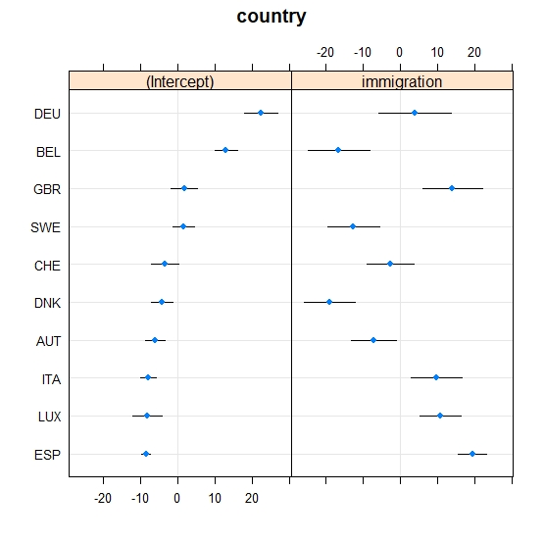

An important result and a confirmation of our previous analyses can be observed in the dotplot of the random effects of the two models, indeed it’s clear how, being an immigrant, living in Great Britain has a positive effect with respect to the mean on the school performances while living in Denmark has a negative one.

* Multinomial logistic regression models

Once implemented the two mixed models for the schools of GBR and DNK we divided the schools of each one in three clusters, ranked trough the effect on the scores as pointed out by the mixed models.

To explore a posteriori these clusters we applied a multinomial logistic model, which allowed us to identify the different characteristics of the best and worst schools. Indeed, the output of these models assign at each covariate a coefficient which increments or decrements the probability of being assigned to the best or worst schools class.

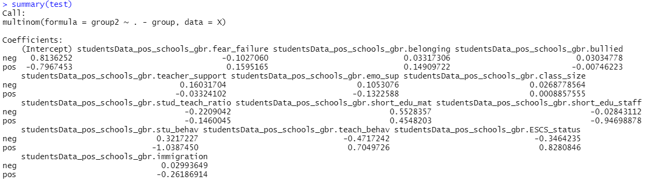

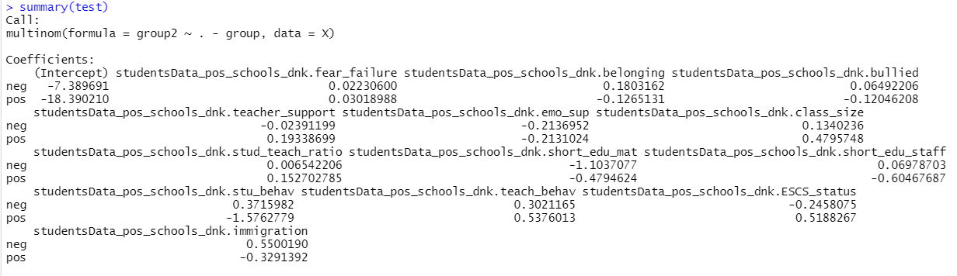

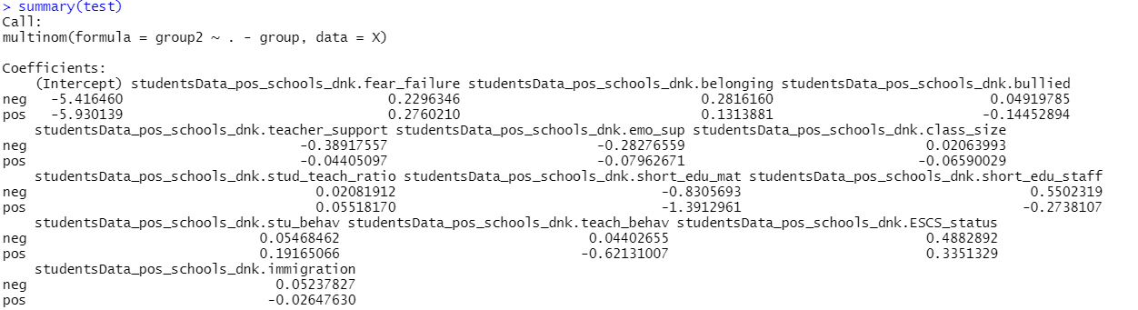

(faccio tabella con questi risultati mettendo asterischi su quelli significativi)

From the tables of the results we notice that in Great Britain the best and worst schools do not present huge differences in their characteristics, except for an higher socioeconomic state of the student and a larger educational staff, which probably ensures greater attention and care towards students. These variables has the same effect also in Denamark, but in addition there’s a relevant worsening in the school climate in the worst schools and, as expected, being an immigrant student increments the probabilities of being assigned to the worst schools class.

1. Results ( what were the results)
2. Conclusions (What do we learn from the results)